CSE 581

**Lab 5: System Functions Exercise**

1. List all employee names in the following format: LAST NAME, first name. (Uppercased last name, followed by comma and space, followed by lowercased first name).

SELECT UPPER(LastName)+ ', ' + LOWER(FirstName) AS [Employee name]

FROM Employees;

1. List all company names as well as the length of their name, from the Customers table. 2 Columns – Company Name, Text length.

**(blank should not count)**

SELECT CompanyName, LEN(REPLACE(CompanyName,' ', '' )) AS [length of company name]

FROM Customers;

1. List all shipped dates as well as expected delivery dates from the Orders table WHERE SHIP DATE is present. (Expected delivery date is 5 days from the ship date).

SELECT ShippedDate, DATEADD(DAY, 5, ShippedDate) as [Delivery Date]

FROM Orders

WHERE ShippedDate IS NOT NULL;

1. List all orders from the Orders table that were shipped in 1998.

SELECT *

FROM Orders

WHERE YEAR(ShippedDate) = 1998;

1. List all orders placed on January 1st 1997, from the Orders table.

SELECT *

FROM Orders

WHERE YEAR(OrderDate) = 1997 AND MONTH(OrderDate) = 1 AND DAY(OrderDate) = 1;

1.

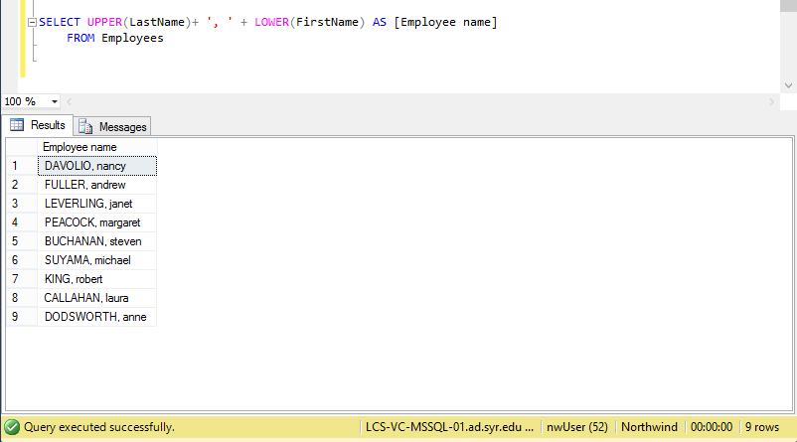

2.

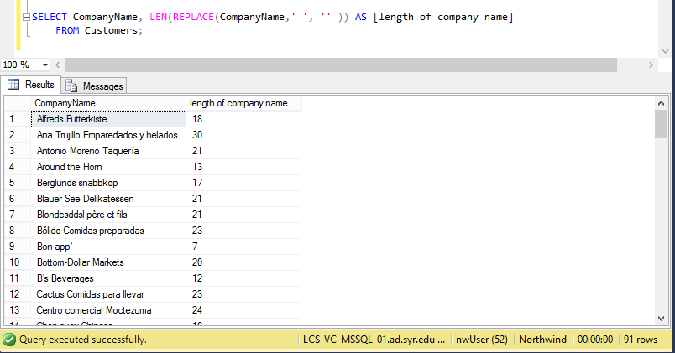

3.

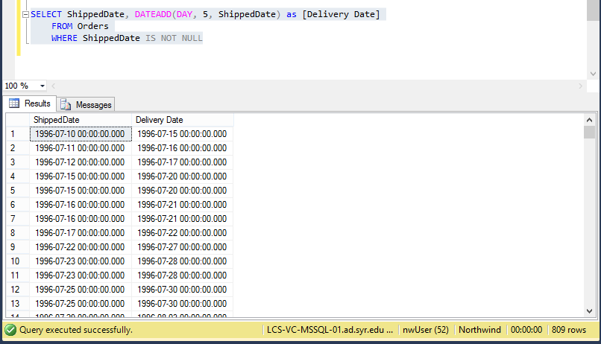

4.

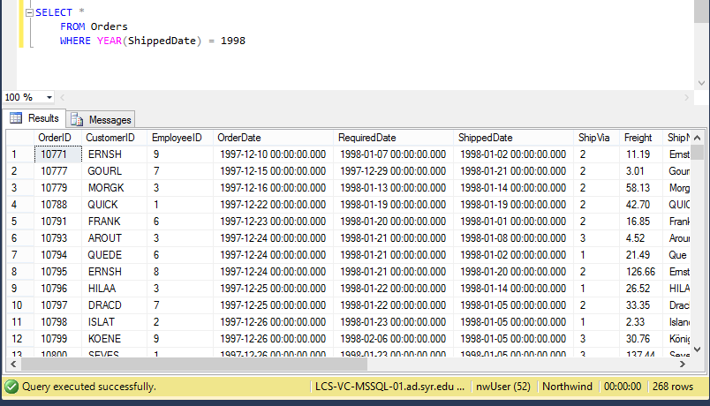

5.

